**JECRC – 45 Days In-campus Training (4 Semester)**

**Subject – Full Stack Web Development**

# Day 6: 21th May, 2024

# Topic – flex

**Assignment 4:-**

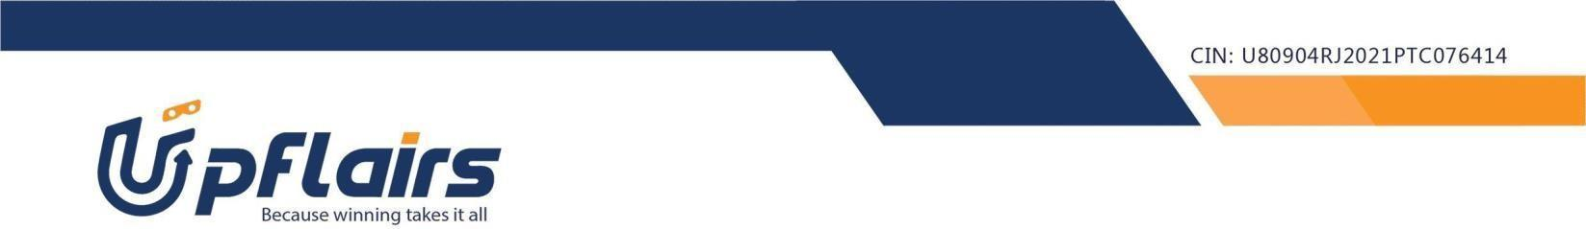 1. make the following webpage -

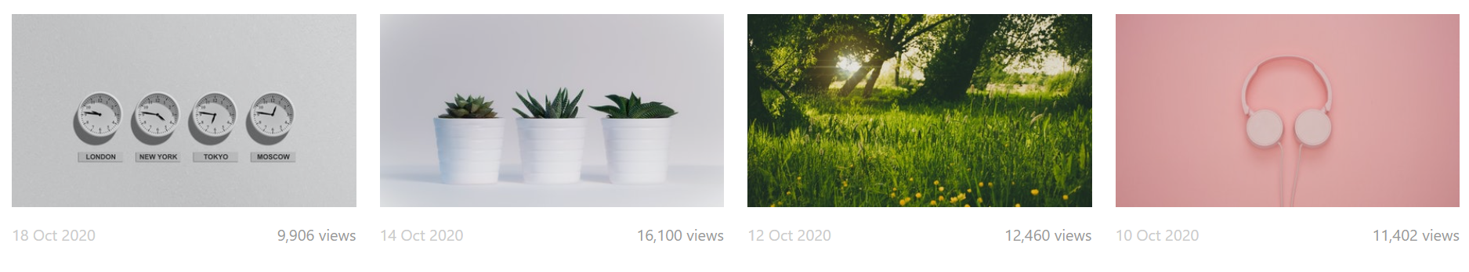

Note- write the code into single html file

Assignment submission form link - https://forms.gle/FDnaoPjarjs1ASbv5